|  |  |  |
| --- | --- | --- |
| Deu_logo | **DOKUZ EYLUL UNIVERSITY**  **ENGINEERING FACULTY**  **DEPARTMENT OF COMPUTER ENGINEERING** | logo-en |

**CME1214 LOGIC DESIGN**

**PRELIMINARY REPORT**

**LAB 5**

**3-bit Synchronous Counter**

**by**

**Mesut Selim Serbes**

**2017510100**

**Lecturers**

**Instructor Dr. Özlem Öztürk**

**Res.Asst. Dr. Feriştah Dalkılıç**

**Res.Asst. Özlem Yerlikaya**

**Res.Asst. Gökmen Katipoğlu**

**IZMIR**

**14.05.2019**

* + - 1. **TRUTH TABLE**

|  |  |  |  |  |  |  |  |  |  |  |  |
| --- | --- | --- | --- | --- | --- | --- | --- | --- | --- | --- | --- |
| **Q2** | **Q1** | **Q0** | **Q2+** | **Q1+** | **Q0+** | **J0** | **K0** | **J1** | **K1** | **J2** | **K2** |
| **0** | **0** | **0** | **0** | **0** | **1** | **1** | **X** | **0** | **X** | **0** | **X** |
| **0** | **0** | **1** | **1** | **1** | **1** | **X** | **0** | **1** | **X** | **1** | **X** |
| **0** | **1** | **0** | **0** | **0** | **0** | **0** | **X** | **X** | **1** | **0** | **X** |
| **0** | **1** | **1** | **X** | **X** | **X** | **X** | **X** | **X** | **X** | **X** | **X** |
| **1** | **0** | **0** | **X** | **X** | **X** | **X** | **X** | **X** | **X** | **X** | **X** |
| **1** | **0** | **1** | **0** | **1** | **0** | **X** | **1** | **1** | **X** | **X** | **1** |
| **1** | **1** | **0** | **X** | **X** | **X** | **X** | **X** | **X** | **X** | **X** | **X** |
| **1** | **1** | **1** | **1** | **0** | **1** | **X** | **0** | **X** | **1** | **X** | **0** |

* + - 1. **KARNAUGH MAPS**

**My number : 2017510100**

**(2) (0) (1) (7) (5)**

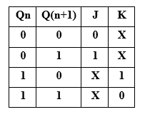

010

000

101

111

001

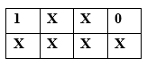

**C:\Users\selim\AppData\Local\Microsoft\Windows\INetCache\Content.Word\J1.png**

J1

J2

J0

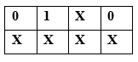

K0

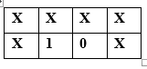

**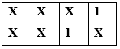**

K1

K2



**J0=Q1’ , J1=Q0 , J2=Q0 , K0=Q2.Q1’ , K1=1 , K2=Q1’**

* + - 1. **LOGIC DIAGRAM**

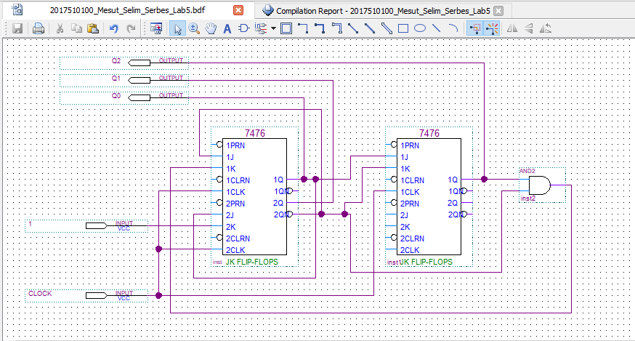

* + - 1. **WAVEFORMS**

**Functional Waveform**

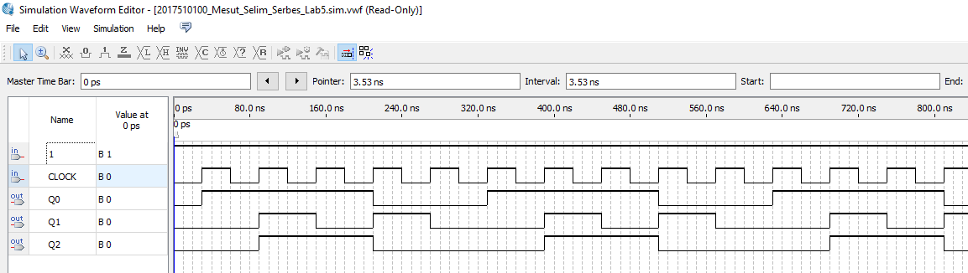

**Timing Waveform**

**